The Waterview Project

Auckland is a picturesque city located in New Zealands North Island. It is a volcanic region and the city is dotted with many small volcanic cones which have become largely parkland where sheep graze and joggers get fit. The city is however snarled in traffic and to alleviate this, Auckland has embarked upon a NZ $1.4bn civil infrastructure program. One essential component is the Waterview Connection, a 2.4km double tunnel that will connect the existing Southwestern and Northwestern motorways. The tunnel is being dug by the Worlds 10th largest tunnel boring machine and serviced by a fleet of Jacon MSVs and MPVs.

These essential machines carry the segments and culverts that form the structural support for the entire tunnel. With a project of this scale and with so many dependencies failure is not an option which is why Jacon’s harsh environment experience and heavy engineering was selected and deployed throughout this project.

Jacon have three classes of machine at work on the Waterview Project. The first is the mainstay MSV which carry the pre-formed segment rings to the TBM for deployment on to the tunnel wall. Each MSV carries a complete ring and a key segment with a total weight of approximately 90 tonnes. These heavy lifters must work 24 hours a day and 6 days per week to keep up with the TBM and ensure the project delivers on-time.

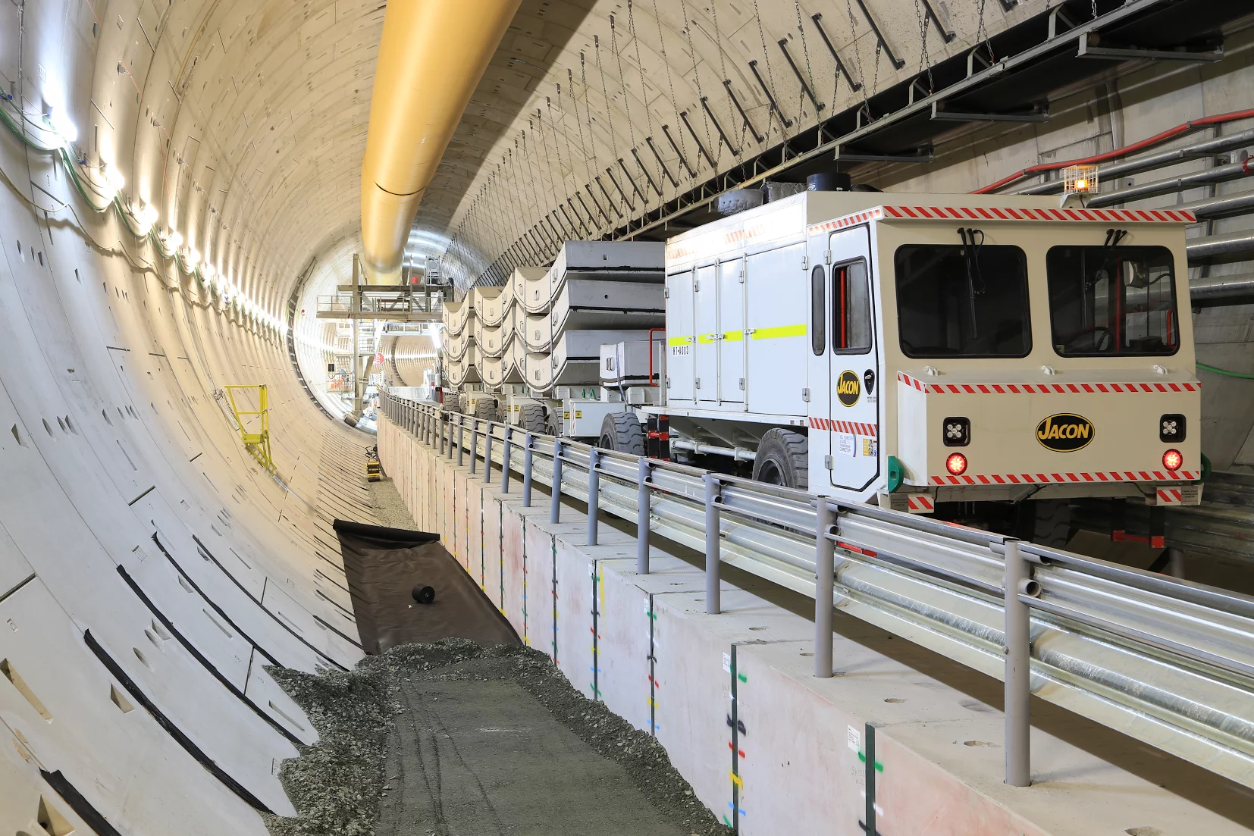
Another ring travels to the TBM.

The second machine deployed was the Jacon MPV. These purpose built machines provide 2 x 15 tonne culverts each trip for the roadbuilding as well as delivering necessary supplies to various worksites within the tunnel.

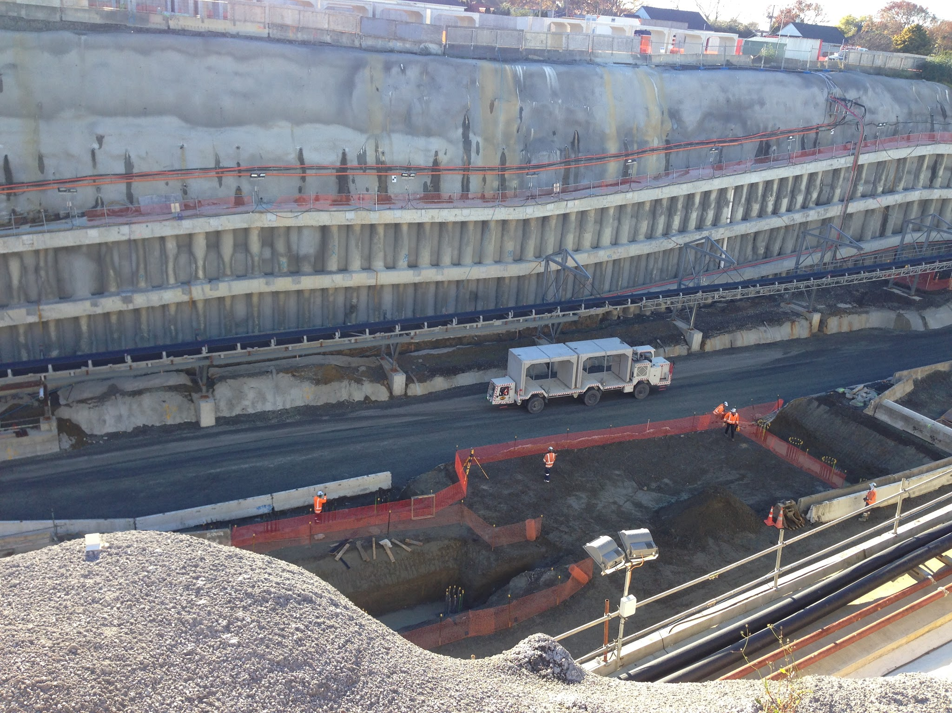
A pair of culverts heads into the tunnel on a Jacon 30T MPV

The chain of culverts provides a tunnel with the tunnel beneath the road surface and allows utilities to traverse the tunnel as well as structural road support.

The final machine deployed by Jacon is a utility vehicle that can be used to carry personnel or material quickly into the tunnel and throughout the site.

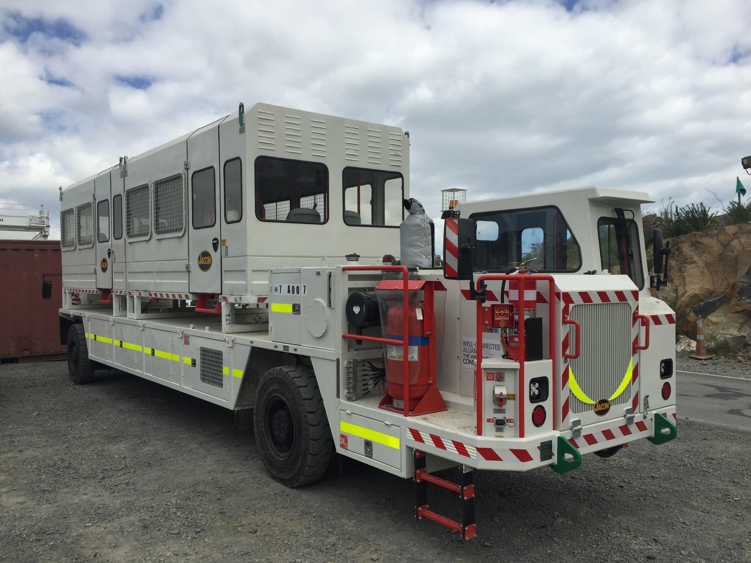

A Jacon Service Vehicle in a personnel carrying role with 2 x Jacon 12 PAX Man pods attached.

Together these machines provide the tunnel movement logistics to complete this important project.

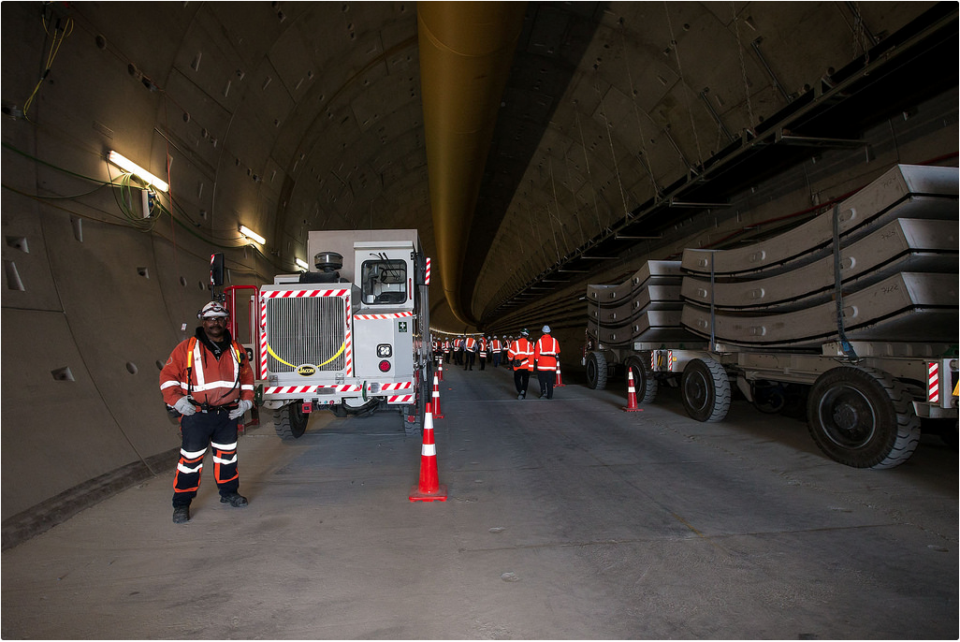
Jacon, relied on everywhere

For further details on the Jacon products and the latest news please visit our website www.jacon.com.au

