Press Release

SBM Proved a Success at bauma 2016:
Record Orders Confirm Customer Confidence
Seven days of intense activity for SBM Mineral Processing! High numbers of trade visitors from around the world, valuable new contacts and a surprising volume of new orders are the highlights of an outstanding fair presence.
The Austrian all-in provider SBM Mineral Processing presented in an informative and welcoming manner tailored innovations for the fields of mineral processing and concrete mixing technology. High-profile trade visitors flowed through the hall: "many customers responded to our invitation, but also valuable and unexpected new contacts with specific projects and inquiries were welcomed by us," said a visibly satisfied Erwin Schneller, SBM Managing Director.
High Level of Interest in New Releases
The SBM double-team of mineral processing technology and concrete mixing technology not only made their presence known with the unique offer of their seamless production, but also attracted the attention of visitors through a wide range of innovations.

For mineral processing technology, the new STE 100.60 jaw crusher with a gap release control that has already been put through its paces, the SMR 13/7/4 impact crusher to shorten the process chain and the next generation of the vertical impact crusher rotor with tripled tool life were presented, convincing the audience with their practice-oriented arguments.
The star for mineral processing technology was, of course, the REMAX 1111 MAXI, which is a result of the SBM development program Best of Both, which became a bestseller.
"It is especially good to hear from our customers that SBM systems focus on the essentials, and in this regard the innovations of the mobile REMAX series also impress. The equipment reliably and simply provides exactly what the customer expects from it," adds Helmut Haider, Sales Manager in Mineral Processing Technology.

For concrete mixing technology, the well-known product range was presented via scale models, among other things, which especially caught the audience's attention. Questions related to the operation of or combination of these flexible equipment systems could be answered more clearly by the sales team with the aid of these miniature versions.
"For us, the large number of trade visitors who have already gathered information on specific projects and who we advised was surprising. In almost all cases, our performance on renowned projects played an important role. Through them we can simultaneously clearly present the performance of different equipment and also show evidence from practice that what we promise here actually works," says Gerhard Gschwandtner, Sales Manager in Concrete Mixing Technology.

A Good Atmosphere
The general good atmosphere was not limited to the traditional Austrian Evening, where invited customers could enjoy various specialities and beer imported from the Alps especially for this event. Numerous orders were placed, resulting in the fair setting a new record. "We could not have predicted a full order book from the fair to the sum of nearly € 7 million. For over half of the orders, there was no preliminary in-house contact, and orders were made directly at bauma, instantly and without hesitation. We are particularly proud of the vote of confidence and satisfaction of our customers, and yet again we have proved that we can stay the course as a unique full-service provider within the industry," Erwin Schneller, Managing Director, summarises the outstanding success at the fair.

A Strong Partner
SBM Mineral Processing GmbH is a full-package supplier of stationary and mobile concrete mixing plants as well as mineral processing and conveying plants for raw material and recycling industries, including service and support. Decades of experience in engineering and manufacturing ensure the company's strength when it comes to sophisticated solutions. SBM systems are designed for year-round operation and are thus ready for use even under extreme weather conditions. The development of high-end components guarantees the machinery and equipment's long life, with low maintenance costs. SBM belongs to the powerful MFL Group. Due to this fact our clients can dispose of the complete company networks concerning know-how, capacities for manufacturing and assembly as well as worldwide dispatch and purchase logistics.

Photos can be used freely with a copyright notice attributed to "SBM Mineral Processing."
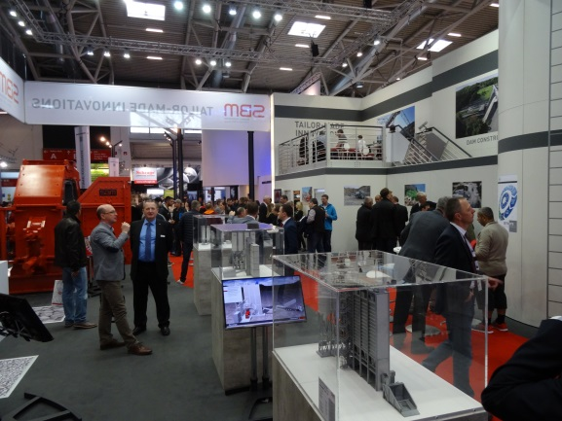 | A high-calibre professional audience at the SBM booth at bauma 2016.

Contact
SBM Mineral Processing GmbH
Oberweis 401
4664 Oberweis, Austria

Cathrin Schupfer
Head of Marketing
Phone: +43 3612/270-1500
marketing@sbm-mp.at
www.sbm-mp.at

